**Mindmap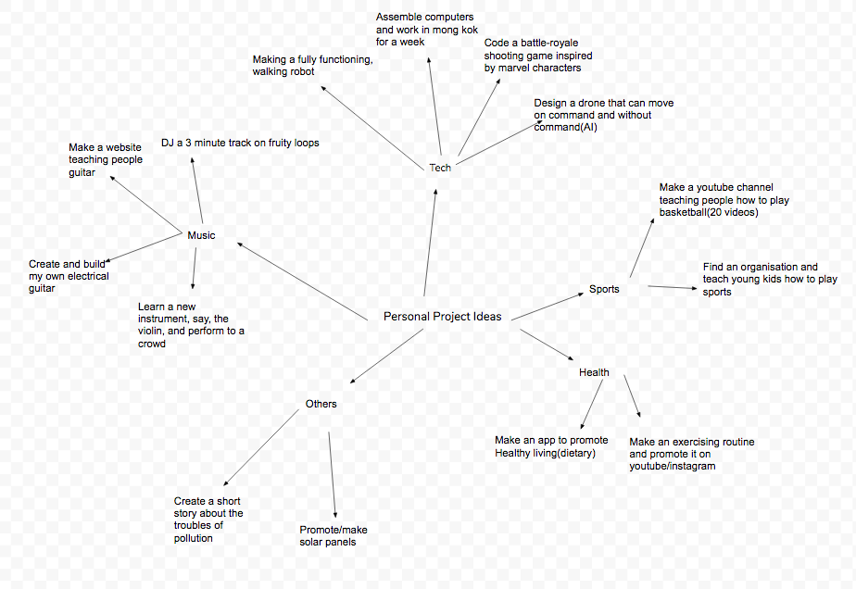 for PP:**

**Criterion A writeup:**

**Goals & Global Context:**

1. What is your goal? What do you want to achieve?

During the timespan of 6 months during PP, I hope to create a basic robot. I will design the entire robot by myself, every individual part. I hope that by the end of 6 months I can hopefully get the robot to run. My ultimate goal is so that my robot can help disabled people and old people when they are walking. I feel life is very tough on that group of people, and I want to help them.

1. What will your final outcome be? How does this product relate to your goal? How will this product help you achieve your goal?

Throughout this project, I hope to achieve the ultimate goal of helping disabled and elderly people with my product. I would ideally allow it to walk by itself, and help other people. This product that I am going to submit for PP definitely will not achieve this, as this goal I am trying to achieve is very complicated. But making a product that can walk and run will certainly be a crucial step that I have to take to get to my goal.

1. What are your personal interests in this project? What experiences, interests and/or ideas make your project important to you.

In general, I really like to explore the area of tech. Since I was young, I have always enjoyed maths, science, and tech. I loved building things from scratch, whether that be a radio, a simple arduino robot, or a huge lego structure. Before, I remember when I used to play toy bricks, my friends and I, we would build a different structure every single day. I really loved that. Now, I try building real things, such as real applications. However, I realised how difficult that actually is. To build something real, you must know so much. In terms of building a complicated app, you need to know how to organise your work, you need to know how to code, you need to know how to design your webpage and UI, and you also need to know how to broadcast it. It is a very challenging project overall. However, I want to use the opportunity of the PP project to actually make something. I have never actually learned anything tech related properly, in terms of classes. I just like to play around with it.

1. How is this goal highly challenging to you?

This goal is such a challenging goal to me. When I set this goal for myself, I actually had no idea of how I can complete it at the end, or even if I can complete it. This goal will mean I would have to devote so much of my time to it. There are so many things that come to making this. First, by getting it to walk, I will have to get it to balance and not fall. This means I have to create a mathematical model relating to AI, that gets the robot to learn by itself how to not fall down. The same goes for running, except getting the robot to run is much harder. Then theres the problem of getting the robot to disconnect from battery, which means it must be able to power itself for some time with its capacitators. There is so much I don’t know.

1. Which Global Context did you choose? How does this relate to your project?

I chose the global context of Science and Technical Innovation. My entire project is basically innovation. I am making something Technical, using Scientific concepts, and it is also an innovative product.

**Prior Knowledge & Subject Specific learning:**

1. What do you know before you chose this project? How is it relevant?

I, to be honest don’t really know much before I decided this project. The reason I chose this project was because I wanted to do something meaningful, and I think that this project that I chose relates closely to my identity. Before this, I had little experience with making robots. I only know how to use robotic sets, and I still have to follow the instructions step by step. I used to be part of Mr. Copeland’s Lego Robotics, and we made a custom robot using the Lego Mindstorms toolkit. We got the robot kit to turn on command, with all kind of sensors.

1. What have you previously learned in subjects, and how will it be helpful to your project?

I honestly don’t know. I’m getting the robot to move, so presumably the motion topic studied in science may help me. Maybe also a bit of Differential Calculus from Maths, even though I wasn’t really taught that.

**Research Skills:**

1. What will you need to research in order to be successful in this project?

I will need to research many things. This includes how to get the robot to move. How to get the robot to not fall. This will involve me delving in to many fields, motion, AI, 3D design, parts and their mates, and different screw sizes. I will probably also need to know a lot of maths, such as calculus etcetera, so that I can plan how the robot will move and how I can subsequently control it.

1. How will you apply what you learn in your research to be successful in your project?

In order to effectively put my research to use, I would need to follow my plan. My plan will tell me what I need to do, and it will include specifications. The specifications will be the guidelines that I will follow and I will use my research to complete my project according to my specifications

1. Look at the ATLS:

**What research skills do you already have?**

I can already research independently online and attend forums to ask my task-specific questions

**What research skills will you need to improve?**

I probably should research more on primary sources, such as books, experts etcetera. This will make my information more accurate.

**Discuss the range of sources I am planning on using()?**

I will be using many sources during the research process. These sources will include online sources, including wikipedia, stack exchange and many different forums and question answer sites. Through this process, I will pick reliable answers over unreliable answers, and will ideally pick detailed answers over undetailed ones. I may look at academic journals when told by people online, or if necessary. I also have many different books related to AI and Robotics at home, which I could sample if necessary.

**Specifications:**

|  |  |  |  |  |
| --- | --- | --- | --- | --- |
| **Specification** | **Detailed Explanation** | **Justification**  **(why is this necessary?)** | **Measurement**  **(how will you measure the success of this?)** | **Success Rate**  **(how well did you meet this specification in the end?)** |
| My product prototype must be finished by the end of November | --- | My product needs to satisfy this requirement as this is mandatory of the project. | I will make sure that my product prototype is finished by the deadline by sticking closely to my timeline and monitoring my progress |  |
| My humanoid robot must be roughly 50cm high. | This means that my humanoid robot, when standing perfectly upright, should stand roughly 50cm off the ground. | On Instructables .com, many of the sample humanoid robots are roughly 50cm tall. | I will measure this specification using a metre ruler. |  |
| The joints of my humanoid robot must be made using servo motors. | Joints are the part of the humanoid robot that rotates and allows for movement of arms and legs. Servo motors allow this by applying effective torques on the arms to get it to rotate. | Servo motors are necessary because many websites, including instructables and wikipedia claims so. Teachers from school, such as Mr. Copeland, also tells me to use servo motors to complete the motion. | I will be assessing this at the end visually, checking if the joints are made with servo motors. |  |
| My robot needs to include the hips, legs, feet, shin and thigh. | Hips, Feet, Legs, Shin and Thigh are parts of the human bones. They together make up the basic structure of the lower body of the human. | These parts are necessary as they make up the main support of the robot. Only after this part is secure can we develop the upper body. | This will be assessed visually, and through expert analysis |  |
| The torque of my robot motors should be roughly 12N*cm | Torque is the ability, or the amount of force it has to get something to rotate. | A torque of 12N*m is enough to lift arms and legs. Many people on instructables.com use identical torques with me, and they have made successful humanoids. It is not really capable of lifting anything too heavy, but it can move itself. | This will be assessed through motor details. |  |
| My robot arms and legs should be designed and 3D printed, designed with Solidworks and printed with a 3D printer | Given that I need to design the robot kit myself, I will be needing to 3D print it,draw it out with engineering drawing software. This means that a 3D printer and an engineering software are all necessary | 3D printers are very versatile tools, and given that my robot is only a prototype at this stage, a 3D printed design is highly suitable. This is based on many websites and suggestions from Robotics teachers at school. As for designing software, there is mainly AutoCAD and Solidworks to choose from, but online forums claim that Solidworks is generally better in terms of 3D drawings and sorting out large component assemblies. | This will be visually assessed by me and my peers. |  |
| My product will contain a clearly visible logo and overall be aesthetically pleasing to my audience | A logo is necessary for many products. Many products are defined by their logos. Additionally, many products are also defined by their aesthetic capabilities, being largely a very aesthetically pleasing design for the audience. | Being aesthetically pleasing is very necessary. Being aesthetically pleasing makes your product stand out, and makes it easier for an audience to remember your product, according to many design website such as uxdesign. | I will consult experts, peers, and I will also conduct self-reflection. I will analyse the results of these and come to a conclusion afterwards. |  |
| My product will be bipedal and will walk on two feet | Bipedal robots are robots that walk on two feet. | My robot will need to be Bipedal because a bipedal robot is one of the defining characteristics of a humanoid robot, which is my project. | I will test it by viewing it, and making sure it is bipedal. |  |

**Personalised Timeline:**

Time Due Task(In detail) How Difficulty and Justification Completion

Difficulty: From 1 star to 5 stars

|  |  |  |  |  |  |
| --- | --- | --- | --- | --- | --- |
|  | Time Due(Estimates) | Task description | How | Difficulty | Finished? |
| 1 | May 6th | Finalise the Topic, Goals and Global Context that I will focus on throughout the PP project | --- | ☆☆☆☆  It is moderately difficult as there is many topics to choose from in this project. Finding one that is of appropriate difficulty is slightly challenging. | Yes |
| 23 | May 14th | Finalise the initial Criterion A writeup reflection | I will use the guide questions from the Files page and answer them accordingly and in detail. | ☆☆☆  This shouldn’t be so challenging as I know the topic, and this is just a reflection with guided questions. | Yes |
| 4 | June 20th | Finish all of my 3D humanoid robotic designs, ready to be printed on the 3D printer | I will be designing my 3D humanoid robot on Solidworks, a highly professional software used for engineering drawings. I will be using assemblies, so I can model all of the rotations that exist on my robot. | ☆☆☆☆☆  This task will be a very challenging task as I have never used Solidworks and have only downloaded it due to my PP project. I am inexperienced, and would probably take plenty of time to finish this step. | Completed |
| 5 | June 22nd | Finalise my biblography and process journal to date. | I will be using Noodletools to cite books, online websites and forums. Additionally, I may also include the names of people I have asked around the community who have helped me, just as a side note. | ☆☆☆  This task shouldn’t be so challenging, as it is simply documenting my progress along the PP journey. I will be sure I document what I did, key measurements, and key changes to what I originally thought of in my plan | Completed |
| 6 | June 26th | Finish 3D printing out all of my robotic parts, ideally with the same color for now. | I will be using either the 3D-printer in my house, or I will go to MakerBay to 3D-print my parts. | ☆☆☆  This task shouldn’t be so challenging, as it simply involves exporting my parts to STL and printing. If I need help I could probably ask for help at MakerBay. |  |
| 7 | July 1st | Finish assembling my 3D robot and connect my wires to the arduino board. | To do this, I would require many screws and bolts, mostly of M3*0.5*8 dimension. In terms of connecting the wire heads, I will be connecting the male header pins to the board, and I will tape the wires together, to limit tangling. | ☆☆☆☆  Assembling will be slightly challenging, as there may be confusion in terms of where I should screw and how I should connect certain components. Regardless, it shouldn’t be so hard, as I would have had software models I can refer to. |  |
| 8 | August 20th | Code the 3D robot so that it can take its first step, without falling | To do this, I would connect the arduino board with my computer. I will code the mechanics of the motion with C, and I will get the robot to move effectively. | ☆☆☆☆☆  This will be very challenging. The robot has a foot surface area of roughly 80cm^2 at max, yet it supports something roughly 50cm tall. This means that losing balance is something that can happen really easily. |  |
| 9 | September 30th | Finalise the walking, and adjust it so that the 3D robot can take a successful step more than 90% of the time. | I will be using the same tools as Step 8. However, I will most likely also be using GitHub, so that I can save all of my codes that I produced in Step 8. This would allow me to be safe from losing work. | ☆☆☆☆☆  This will be very challenging, as increasing the accuracy of the robot will probably be even harder than making the robot walk itself.I need to research countless articles to assess what went wrong each time, and fix it to make my robot more stable. |  |
| 10 | October 7th | Reprint my entire design, and assemble it together again. | I will be using a 3D-printer, same as Step 6. As this is the second time, I will most likely take less time, however, school work also needs to be factored in. | ☆☆☆  This task shouldn’t be so challenging, as it simply involves exporting my parts to STL and printing. Additionally, I have also done it beforehand |  |
| 11 | October 14th | Decorate my design, especially the logo, with different colours, such that it becomes an aesthetically pleasing design. | I will be colouring the robot. The surface is most likely layers and layers of plastic, so Acrylic paint will be the best choice. I could choose to paint with solid colours, or I could paint a design. Regardless, I will be making my design, and my logo, aesthetically pleasing. | ☆☆☆☆  This task might be challenging, as I generally don’t have much experience with painting plastic. However, I have learnt art at school before, and there are many people at school that I can ask for tips, so this shouldn’t be that difficult. |  |
| 12 | October 20th | Assemble my final robot, with my printed and coloured pieces, my servos, and the successful code created in step 9. | I will be assembling the robot from scratch again. I will implement my code, test the robot one final time, and that will be it. | ☆☆☆  This task shouldn’t be so challenging. At first, it should be, but I have already done this before once, so this should be quite easy. |  |
| 13 | November 14th | Finalise updates on process journal and update biblography | I will complete my biblography on Noodletools, as always, and I will make sure to cite all published external sources. I will also include the names of experts around the community that I sought information from in my bibliography. This way I will give credit to everyone. | ☆☆☆  This task shouldn’t be so challenging. I will be sure to document along the way of the creation process, but I would have to finalise it as well, preferably a couple weeks before the deadline. |  |

**Time and keeping up to date:**

June 22nd:

|  |  |  |
| --- | --- | --- |
| **Entry Date** | **Details** | **Changes to Timeline** |
| June 22nd | Today I managed to finish my robotic designs, ready to be printed on the 3D-Printer. | This was a little behind schedule. I was a little busy during the last week of school, having to sort out PP meetings and plans for the summer, so I did not complete this at the scheduled time, June 20th. |
| July 1st | Today I successfully printed out 2 parts of my print | I consider this print to be failed as after the print, I realized that |
|  |  |  |
|  |  |  |

Today I have completed the basics of my steps and my research that I have completed during the designing of my robot. I documented my general process, and the sources and information I looked at when I first started. For my bibliography, beside my information, I documented the websites that I used.

**Initial Ideas/Existing Ideas sampling:**

1. **Poppy Humanoid Project**

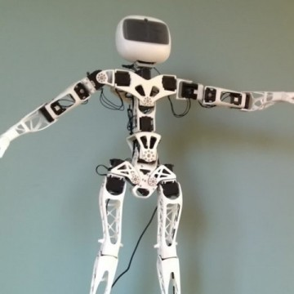("Poppy Humanoid," 2012).

Description:

The poppy humanoid project is an open-source humanoid project. It is designed by Generation robots,and fulfills my criteria of being a bipedal humanoid robot able to walk and run. The designer files for this robot can be downloaded, which I did download and sample with my solidworks application on my PC. My servos will be slightly different from the servo used by this project, as the project uses much better servos than mine, servos MX64 and MX28(Documented in equipments), with torques much greater than I need it. ("Poppy Humanoid," 2012).

1. **Inmoov**

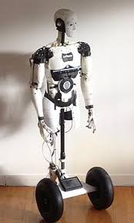

Inmoov is a rather professional robotics open-source project. It claims to be the first open-source project for life-sized robots worldwide. It’s founder was a robotics engineer who created this project with the purpose of helping people with disablities, focusing especially on Proesthetic hands. This robot is very complicated, as it has many degrees of freedom(Documented in features), 6 for the head, 5 in each arm, 10 in each hand, and the robot also has many different complex sensors. Many body parts are involved in this humanoid, biceps, back, faces and jaws, eye mechanisms, mid and low stomach, skull, torso, and various support. Each of these parts are built together with many individual 3D-printed parts. It may be a little bit too professional to be modeled, but I downloaded the STL files anyway.

Link:

<http://inmoov.fr/>

1. **Otto Humanoid**

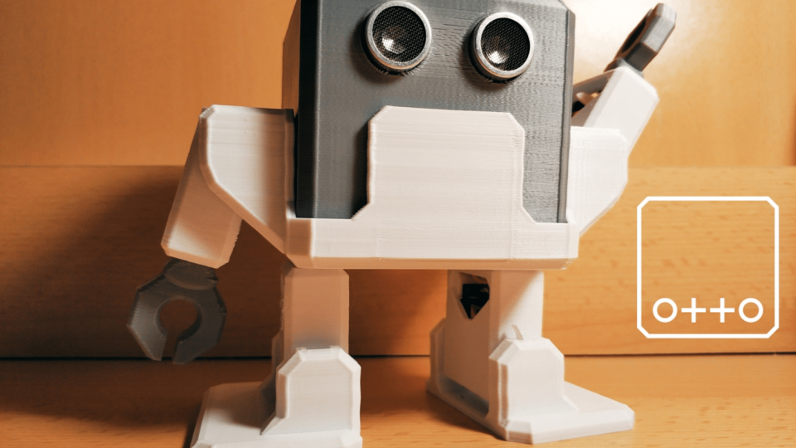

This humanoid project is slightly underdeveloped and less well known, but it is also open-sourced and free for everyone to use. The robot is a simple robot, consisting of two arm parts, two leg parts, and one small torso to connect them. It looks generally quite easy to make and quite easy to balance. It apparently can dance, can walk and has various sensors. It uses arduino NANO shield.

<https://www.personalrobots.biz/otto-humanoid-is-the-best-robot-companion/>

**Notes:**

Overall, I think that it seems the Poppy Humanoid project is the best choice. Overall, it doesn’t look as aesthetically pleasing than the Inmoov robot, with it’s very many parts and outside covers. However, it is quite complicated as well compared to the Otto Humanoid, which may look something like what a 7th or 8th Grader would build, too simple. Overall, I can implement ideas for all three, but I think that the Poppy Humanoid Project is probably the end humanoid that I would be going for.

**Initial Designing:**

**Initial Choices:**

**Modeling/Sampling & Equipment:**

I have chosen to model the design Poppy Humanoid. The project itself has 25 DOF(Degrees of Freedom). Designing this project is very complex, as the project itself was founded and designed in 2012 by a PhD student. Thus, I have chosen to create the robot only to the pelvis, to achieve the balancing aspect first. Basing off the Poppy design, this means that my robot will require 10 degrees of freedom, 2 at the foot, 2 at the major leg joint, and 6 at the hips and pelvis. In terms of motors I believe I will be choosing the motor Motor 1501MG. It is a fair motor choice in terms of torque, size, and weight for its price. It’s relatively cheap for its functionality and the torque offered, 15-20kg/cm. Given I need 10 different motors, this seems a pretty good choice. The model of this motor is also very common, as many different motors, including HV2060MG(Documented) and arduino motors all follow a very similar design. Thus, I could easily switch over to a different motor with a higher torque, lower weight, or faster rotational speed if I so require. All I would need to change are some of the dimensions.

**Tools & Basic Procedure:**

Based off some research, I have decided that Solidworks will be the

Designing software:

Motor SR1501:



This is a picture of my purchase of the Motor documented in my process journal as Motor 1501MG. I bought the servo with a single axis as that was how most robots are built. This was bought on Taobao from a shop in ShenZhen. The model is slightly different from the researched one, and this product is made from a factory in Dongguan. After I purchased this motor, I immediately began sketching it.

It took me roughly a full 2 weeks to simply sketch out the outline of my motor on 3D-CAD tools. This was mainly because of my lack of experience in using this tool, as this was my first time encoutering it. The tool I used was Solidworks, a highly professional and cutting-edge technology. Using specialised Calipers(Documented in equipments): Here are some of my measurements:

Measured:

-Radius of the circle for the screw on the top of motor:2.34mm

-Distance of the circle for the screw to the center: 7.05mm

-Radius of the big circle on the top:20mm

-Thickness of the upwards circle: 2.06mm

-Side shape top length: 11.78mm

-Side shape middle length: 16.74mm

-Height of the bottom part of the spinny thing:3.6mm

-Height of the bottom part: 4.9mm

-Distance between the outside tangent part of circle to circle:1.84mm

-Radius of the bottom part of the upwards circle: 8.08mm

-Bottom shape length: 9.5mm

-Distance between the top of the upwards circle and the bottom: 6.3mm

-Width of the whole part:3.24mm

-Distance to the ends: 2.95

-Thickness of Holder: 2.2mm

These are some pictures of me measuring the distances of the initial Motor using a Caliper.

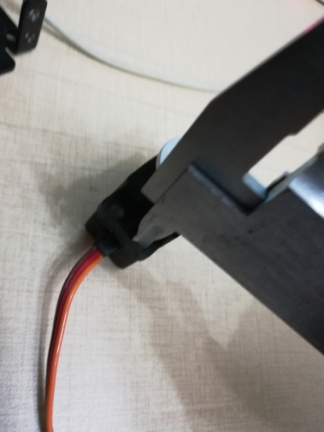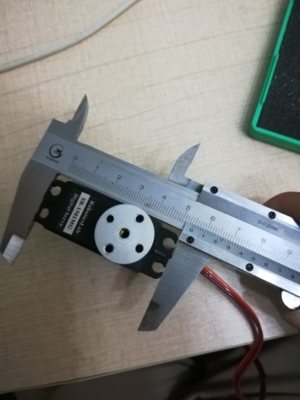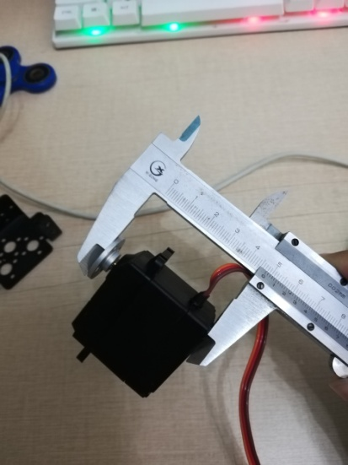

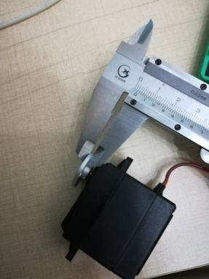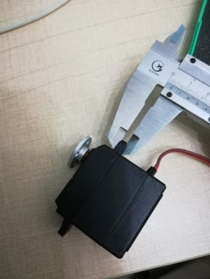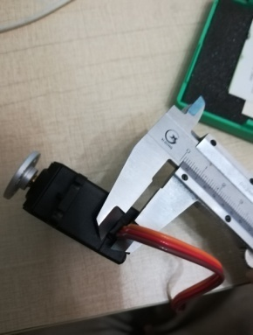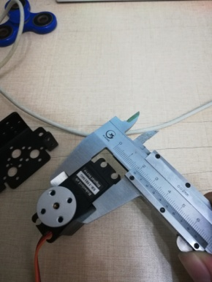

Here are some pictures of me drawing out the motor:

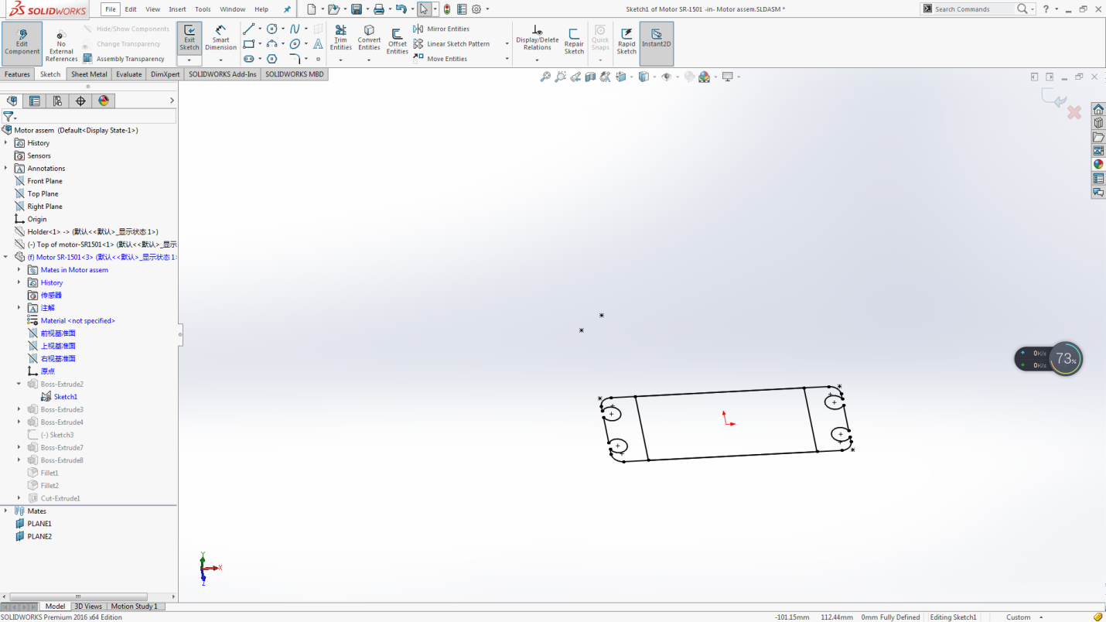

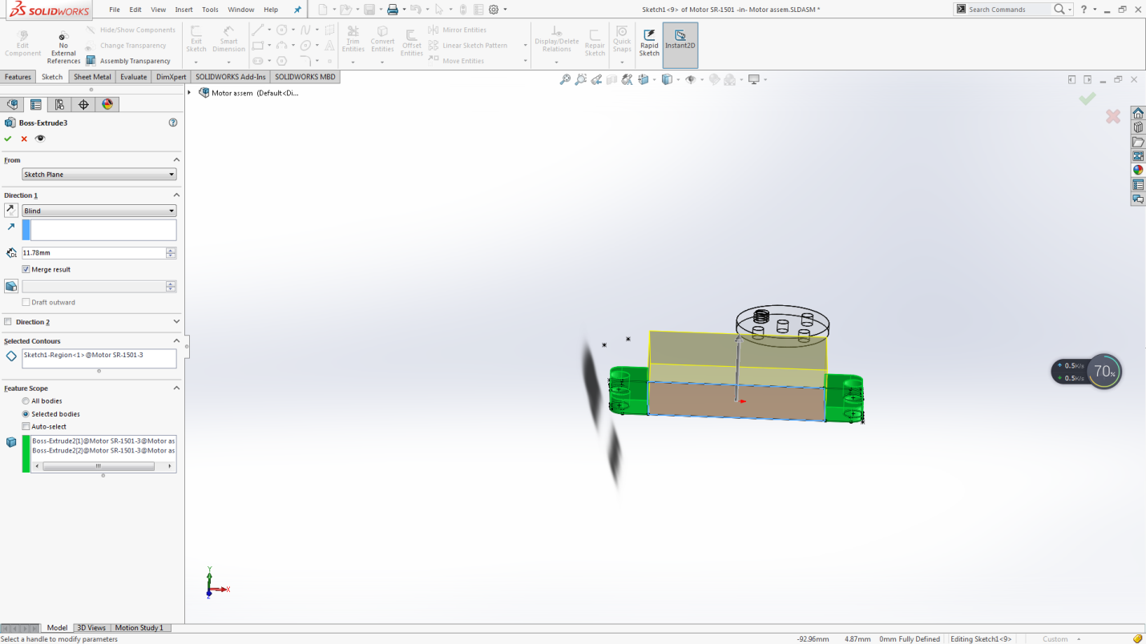

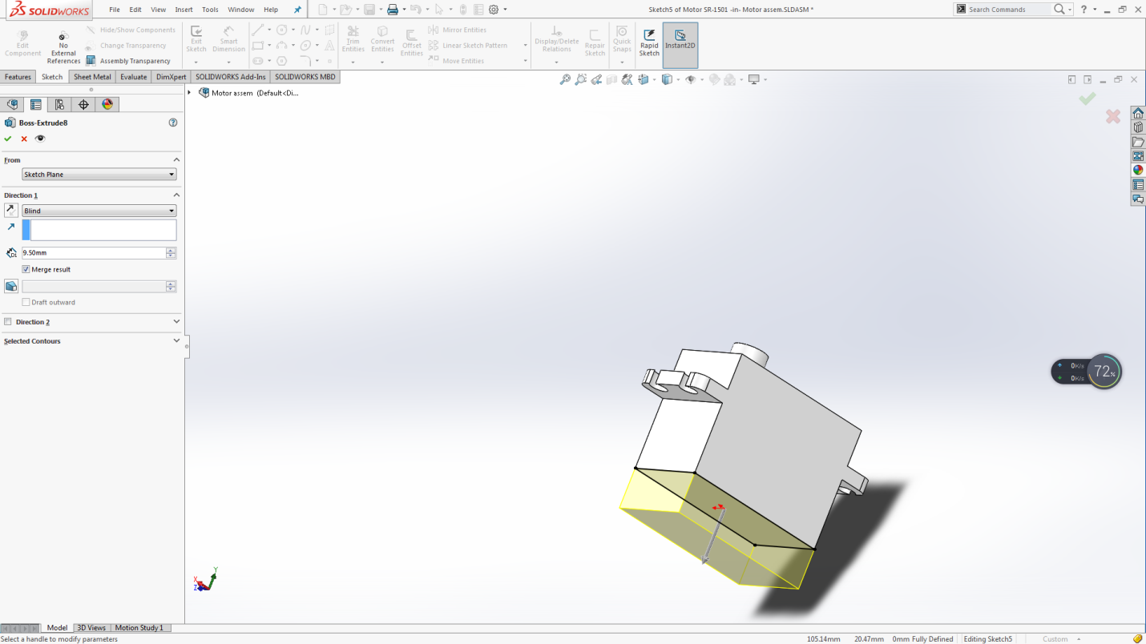

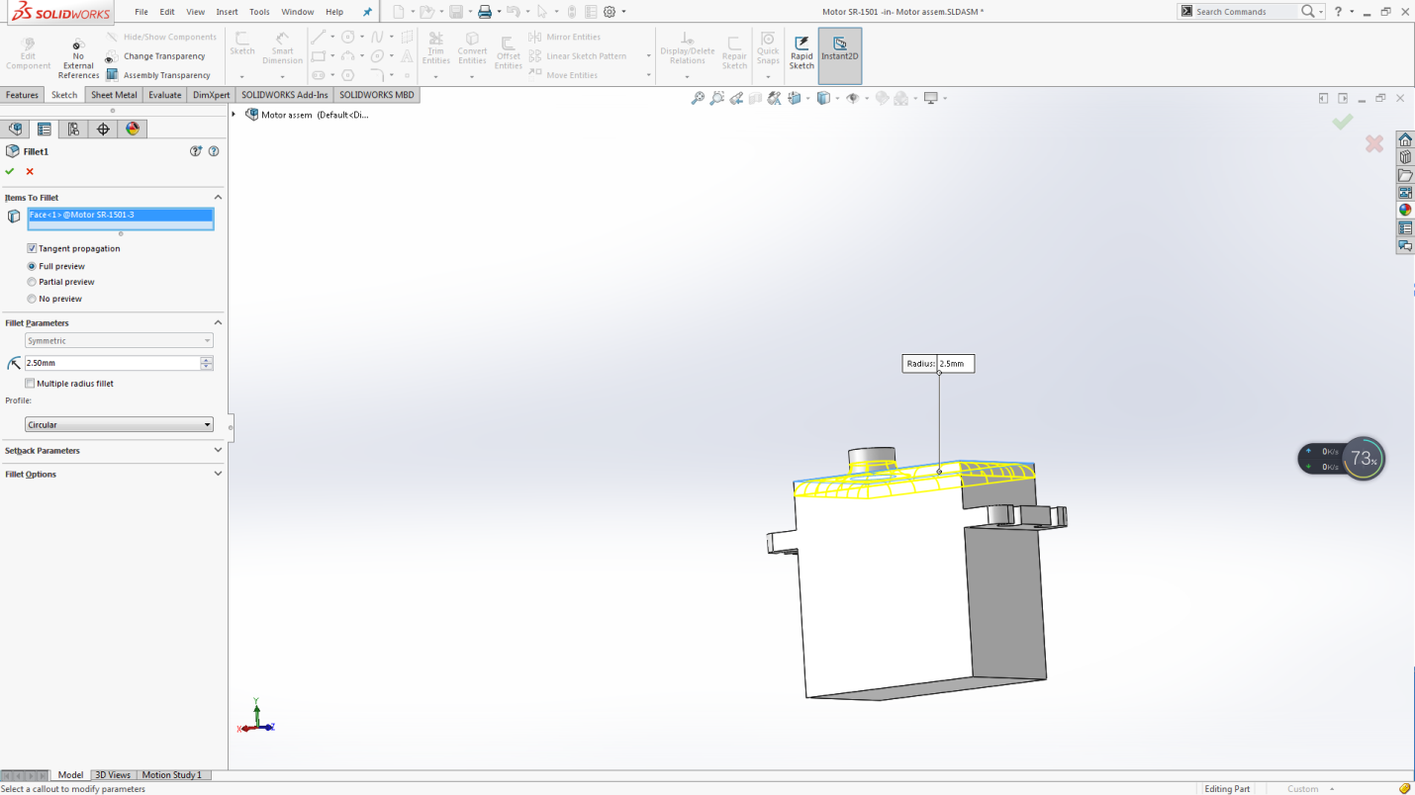

Final Sketch:

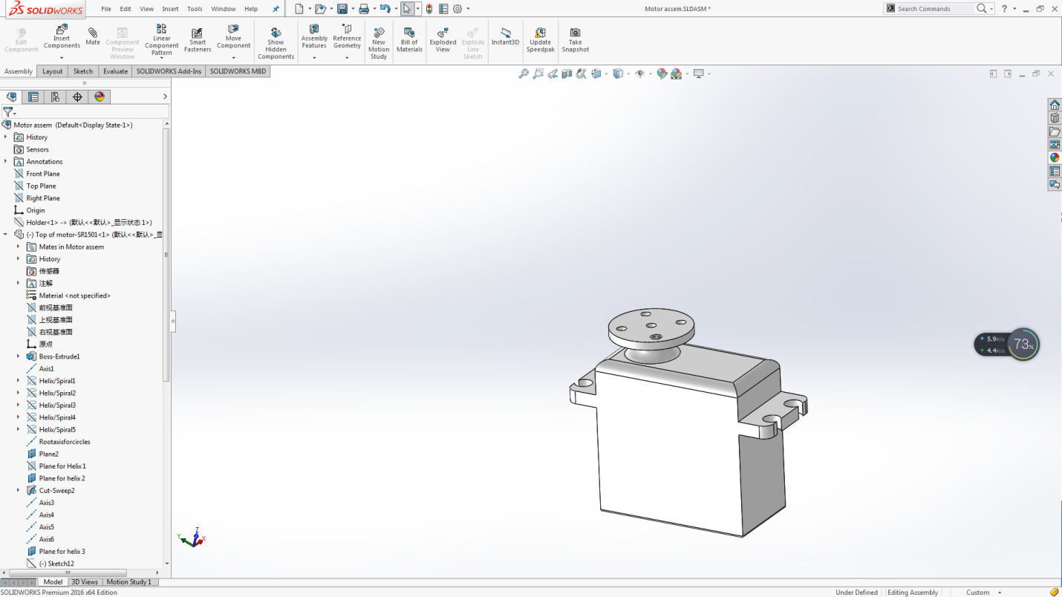

Actual Product:

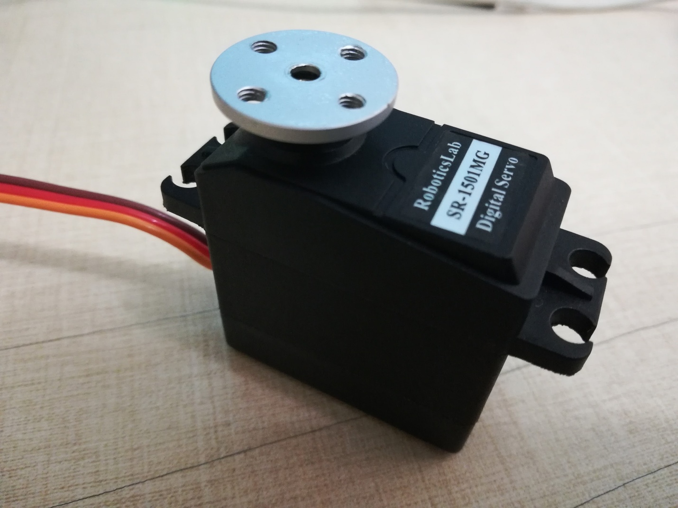

Reflection:

May 8th

This was my first CAD drawing on Solidworks. The features involved were only simple extruded boss bases, extruded cuts, and fillets here and there, however, this part took me roughly 2 weeks to nail. Many of my issues were largely due to:

* Measurement inaccuracy, as it took me quite a long time to nail many different measurements, such as the measurements for the radius of the small holes. The small holes all have a really small radius, roughly on the level of a few milimeters. I kept on using the lower jaws for that measurement. That required me to position the caliper myself, with my eye, causing much inaccuracy. the measurement was never quite accurate. It was due to a youtube video that I learned that I needed to measure with the upper jaw instead. Many measurements I had to measure over and over again, as the previous measurement that I documented just didn’t seem to be right after measuring again.
* Sketching difficulties. As a newbie into this 3D-CAD atmosphere, it may not be very surprising that I encountered many sketching difficulties. Many different things led me to confusion, including filleting, sketching lines and curves, and trimming. Many errors showed itself, including errors related to tangency properties, overdefining, and concentric rotations. I accidentally made a mistake of fixing the center of a circle in relation to the origin, and then defining that again, tangent to the rectangular lines. I thought both properties should be able to be achieved due to the product’s positioning, however they aren’t. Another error that was really annoying was when I was sketching the main extruded sketch, the holes took me really long to draw. The holes weren’t really holes, more like an opening from the edges, as they were connected to the edges. I tried sketching them as arcs. It worked, but I noticed an asymmetry between the holes on one side and the holes on the other. I tried changing them, but I couldn’t. Every single time I tried to trim of the unwanted edge, the program keeps telling me “This sketch is over-defined.” I tried mostly everything, unfixing points, removing unnecessary sketch dimensions, but I couldn’t fix the problem. I could not make sense of it at all. I was frustrated, as I just couldn’t manage to figure out what features and properties were causing the error, so I was forced to start from scratch. This time, I took suggestions online and I trimmed the edge instead. I tried to stop fixing points in place, as I felt that was a major causal factor in my over-defined errors. The fillets were quite new to me as well. I wasn’t so sure how to start with that, and the different types of fillets involved. Overall, it worked out quite nicely in the end.

**Holder drawing:**

As we see, the motor shown in the diagram does not have screw holes attached on the opposite side of the hole. This means that the Motor itself will not be able to turn around an axis, as it is supposed to do. Thus, in order to allow the motor to function, we will have to provide a Holder part, similar to the below diagram:

As for the holder part, I designed it

**Building:**

**Final Equipments needed:**

- 13 SR-1501MG model motors, bought from 深圳智能宝贝机器人. 10 needed, 3 for backup

- 20 Circular rotating shafts for the motors, 10 needed, 10 for backup

- 60 M3*7 screws and nuts, 50 needed, 10 for backup

- 20 sets of axial motor equipments, including an M3*10 screw, a rotating axis, and an M3 nut

- 60 M3*5 nuts and screws, 50 needed, 10 for backup

- An arduino controller board

- 50 sets of nuts and bolts for M4*8 screw, used to secure the screw and motor. 40 are needed, 10 are for backup

- Many rolls of PLA plastic, used for 3D printing

- A 3D printer and 3D printing software

**3D-Printing:**

**Foot part:**

In order to 3D-Print my parts from my CAD software, Solidworks, I tried two different options to convert my file into a printable STL.

* Click save-as, and save the file as a new file, being sure to choose the filetype STL to save as
* Press the option Files->Print 3D and the STL file of the same name will be automatically created in your chosen directory.

These options both work - they both produce a suitable STL.

However, the second option, based on testing, sometimes produces a corrupted .gcode file when I put it through the Cura software. That option corrupted my first part, and gave me a print that was unsuccessful - a 3D print that had only the base part of my foot.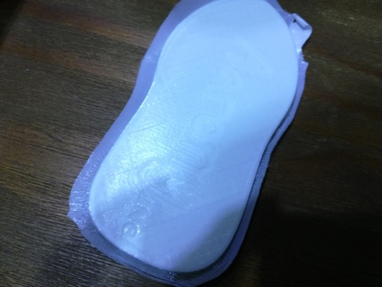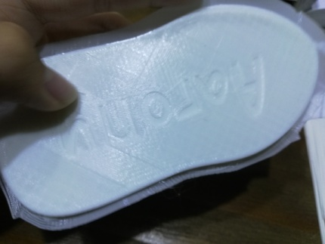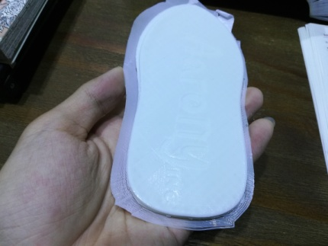

Two major problems arose during the process of printing this. First, my .gcode itself was corrupted and had problems. It did not layer my foot as expected and only layered the bottom(the base) of my foot, as shown. Another major problem was that the base of the print moved. The print itself was not tightly bound to the print bed. Before the print, I stuck paper to the print bed flat tightly, with double sided tape, so that my body can be easily removed from the print, and will be less likely to stick to it. However, I did not realize that the paper itself actually expanded amid the heating of the bed. The paper occupied more volume and area compared to before due to the heating, and thus turned into a very curved shape. This caused my print bed surface to be curved. This was a big problem, as it messed up the entirety of the positioning of the printed part. The filaments for my support were messed up and the lines did not match each other(As shown below)

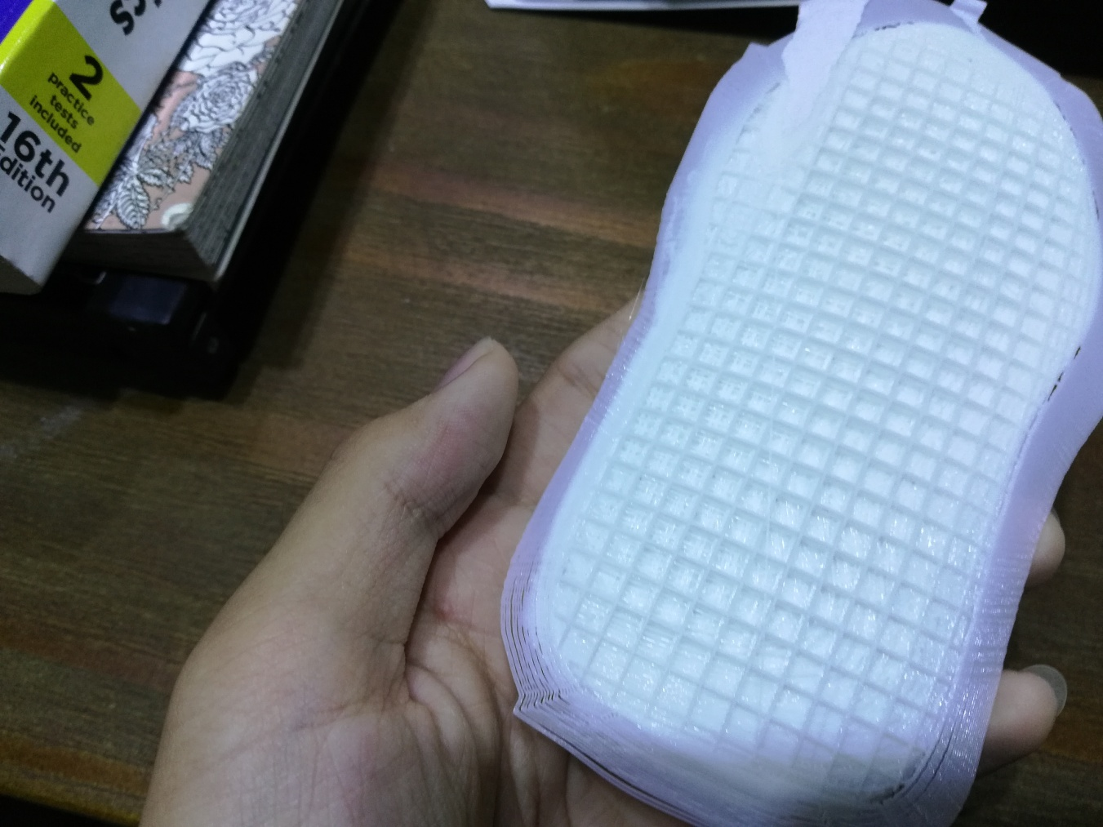

It printed everything else as expected, the brim support, my gridline support, and my curved foot base, however. Afterwards, I removed the paper and I tried again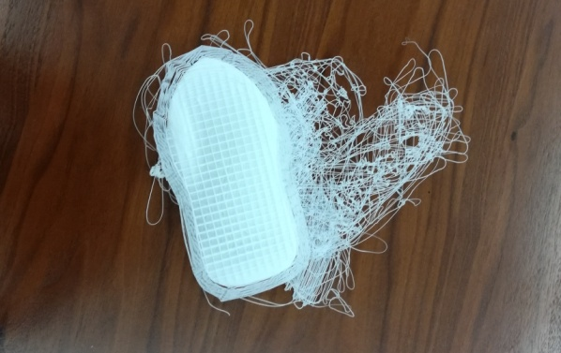, this time a worse fail. The base piece was so badly attached to the print bed that it managed to be completely taken off the bed by the thermoplastic extruder.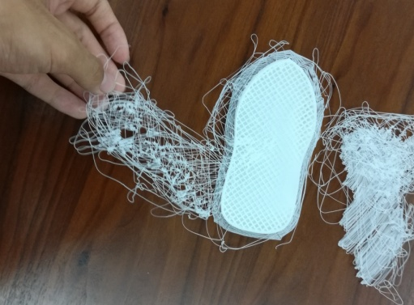

For my final print, I google searched possible reasons to what I am seeing. It turns out that my main mistake was in not adjusting the distance correctly between the thermoplastic extruder. That distance needs to be manually adjusted, at around 0.1mm, and needs to be very accurate. After reading these blog posts, I carefully adjusted the distances between the printer bed and the extruder. I made it much closer to each other. This time, the print was very successful.

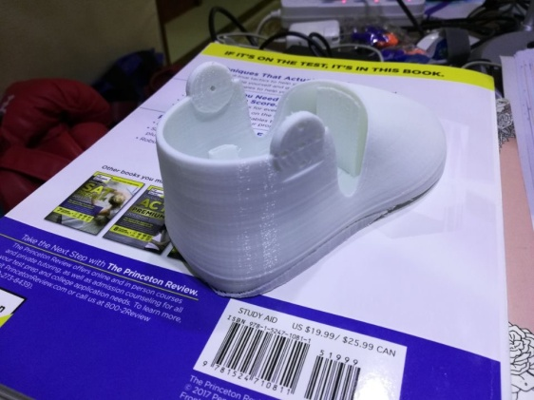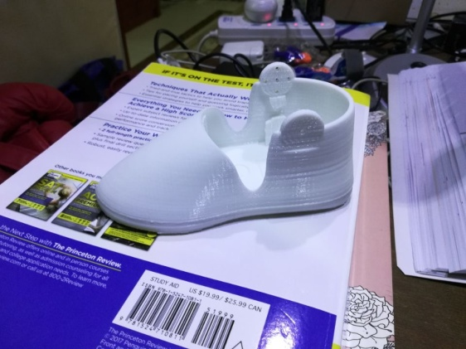After I printed all of the parts, I realized that I accidentally drew the motor holes too small. At first, I measured it as a hole with diameter 2.34. However, the robot that I modeled had a screw size of diameter 3. Initially I thought, since it was plastic, this difference could be fixed simply by drilling the screw into the holes forcefully, but that turned out to have no chance of working. It was a successful 3D print, but yet it was also a fail.

For my pelvis part, I want mainly two different shapes of extrude. This is why I will boss extrude the first interface, and then cut extrude to get two different shapes.

**Documentation:**

**Parts of a 3-D printer:**

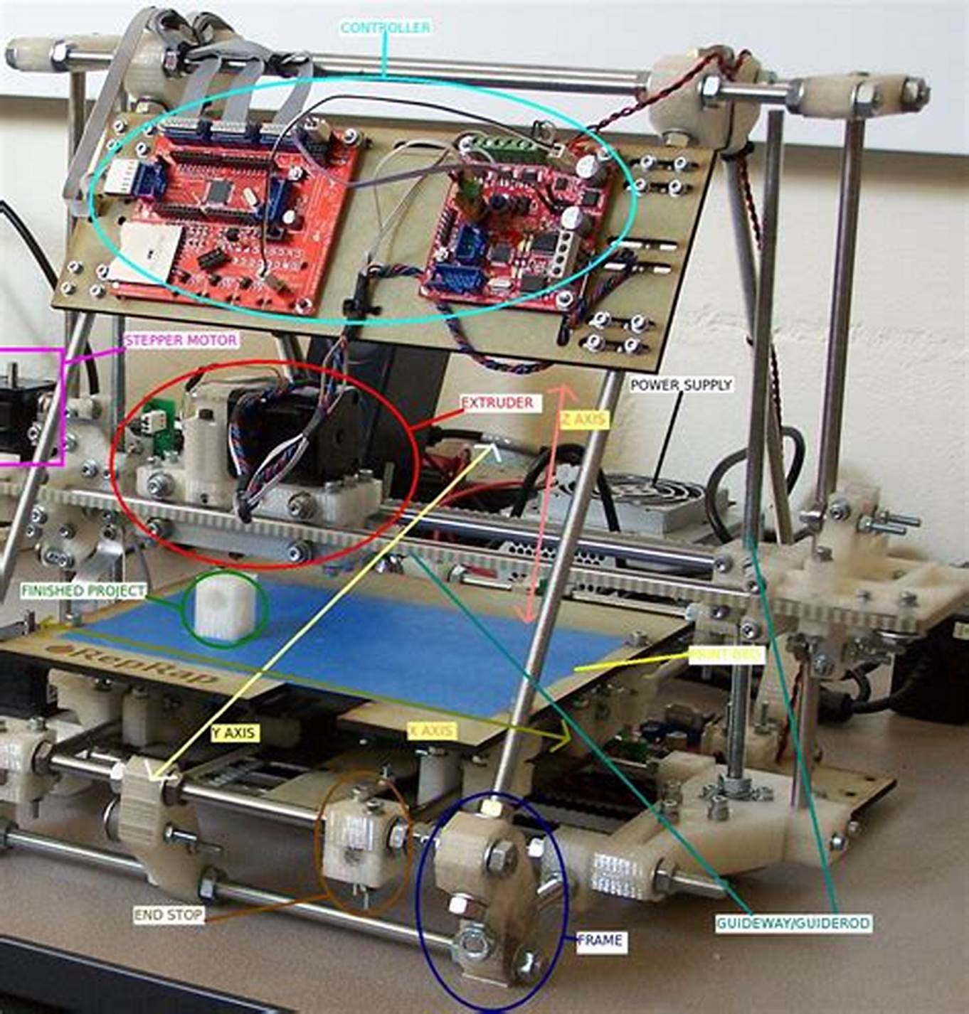

<http://allabout3dprinting.com/the-parts-of-a-3d-printer/>

A 3D printer is a complicated mechanic with many different parts to its system. The 3D printer is capable of moving in all three directions, with three degrees of freedom. In order to achieve this, a 3D printer has many motors, including a belt, which move the main nozzle along the bed plane. A 3D printer also has a nozzle, or more precisely, a thermoplastic extruder, which is responsible for melting the plastic material used and squeezing it out onto the print bed. It can squeeze out plastics through holes of different diameters at a time. The 3D printer is generally a quite precise machine, with the smallest distance that can be moved in either direction in some machines hitting around 0.02mm. This means that the 3D printer can print virtually anything, be it large or small.

Cura is the software I am using to create .STL and .gcode files for my print. In Cura, I would add support structures, rotate my model as I wish, and send my model to the 3D printer.

**Plastics Used:**

<http://www.tridprinting.com/Compare-PLA-ABS/>

Two main types of plastics are used when it comes to 3D printing. These types of plastics are:

- ABS plastic

- PLA plastic

Both plastics have their separate pros and cons. Mainly, we have that ABS plastic is based off petroleum, and PLA plastic is made from plants that are relatively rich on starch. PLA plastic tends to droop when temperatures are hot, which may influence the print quality. ABS plastic tends to require hotter temperatures from the print bedOverall, the strength of an ABS plastic print is generallly the same with PLA. ABS is slightly toxic when printed, meaning that it is not a very safe print at a home environment. PLA, when under stress, breaks into many small pieces, whilst ABS tends to bend before breaking.

**Adhesion:**

Adhesion is a very common problem in 3D printing, and I have encountered it countless times when printing. The 3D printer prints from bottom to top. Thus, the bottom layers need to be secure before the new layers can be printed. For most 3D printers this isn't a problem, but what often happenes is that the print itself may not adhere, be firmly attached to the bed it is sitting on. The print may be moved left, right , front or back accidentally, usually by the nozzle. This causes a mismatch in position, and a messy and failed print. Many supportive structures, such as brim and raft, are usually printed to prevent this problem. They print large, extra layers at the bottom of the bed, to increase the contact surface area with the bed, and then begin printing the actual model. This way, the print is much more likely to adhere to the bed. Another major component that can benefit adhesion is the initial distance between the bed and the nozzle, typically called the 'z-offset'. This value can be changed and adjusted by the user themselves. Typically, based on experimentation, I like to put this value at roughly 0.06mm, at a papers thickness. This works quite well for me.

**DOF(Degrees of Freedom):**

The simple way to explain the degrees of freedom of something is the amount of variables needed for us to know exactly where it is. For instance, a simple lever attached to a wall, or a hinge, has one degree of freedom, as only one variable, namely the angle the lever or the hinge makes, can change. Knowing that one variable defines the position of that object. A point on a two dimensional sheet has two degrees of freedom, as two variables define it’s position. A ball in 3 dimensional space has 6 degrees of freedom, as the ball can move along three different axis(translational degree of freedom), and can also rotate along three different axis(rotational degree of freedom). For a robot, the amount of things that can be moved in the robot, that is, the amount of separate parts of the robot that can move, defines the degrees of freedom of the robot.

<https://www.cs.cmu.edu/~rapidproto/mechanisms/chpt4.html>

**Equipment(Motor):**

**1501MG:**

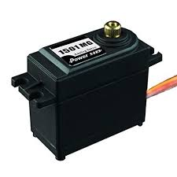

Torque: Between 15kg/cm and 20kg/cm

Angular Speed: 0.14sec/60degrees to 0.16sec/60degrees

Weight: 60 grams

Size: 41.9*20.6*39.6mm^3

Gear type: Metal

Price: 13.30 U.S dollars

<https://servodatabase.com/servo/power-hd/hd-1501mg>

**MX64**

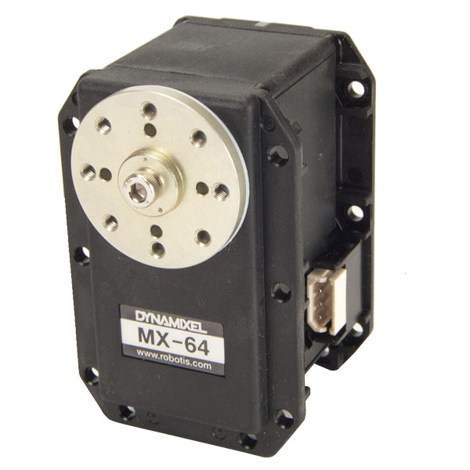

|  |  |  |  |
| --- | --- | --- | --- |
| Operating Voltage | 14.8V | 12V | 11.1V |
| Stall Torque* | 74 kg·cm  1033 oz·in  7.3 N.m | 61 kg·cm  849 oz·in  6.0 N.m | 56 kg·cm  778 oz·in  5.5 N.m |
| No-load Speed | 78 RPM | 63 RPM | 58 RPM |
| Weight | 126g | | |
| Size | 40.2 x 61.1 x 41.0 mm | | |
| Resolution | 0.088° | | |
| Reduction Ratio | 1/200 | | |
| Operating Angle | 360° or Continuous Turn | | |
| Max Current | 4.1A @ 12V | | |
| Standby Current | 100 mA | | |
| Operating Temp | -5°C ~ 80°C | | |
| Protocol | TTL | | |
| Module Limit | 254 valid addresses | | |
| Com Speed | 8000bps ~ 3Mbps | | |
| Position Feedback | Yes | | |
| Temp Feedback | Yes | | |
| Load Voltage Feedback | Yes | | |
| Input Voltage Feedback | Yes | | |
| Compliance/PID | Yes | | |
| Material | Metal Gears &  Engineering Plastic Body | | |
| Motor | Maxon RE-MAX | | |
| Manual Download | [MX-64 Manual](http://support.robotis.com/en/product/actuator/dynamixel/mx_series/mx-64(2.0).htm) | | |
| Controller List | [ArbotiX](http://www.trossenrobotics.com/p/arbotix-robot-controller.aspx)  [ROBOTIS CM-530](http://www.trossenrobotics.com/p/cm-530-robotis-servo-controller.aspx)  [ROBOTIS USB2DYNAMIXEL](http://www.trossenrobotics.com/robotis-bioloid-usb2dynamixel.aspx)  [ROBOTIS CM-700](https://www.trossenrobotics.com/store/p/6410-CM-700-Robotis-Servo-Controller.aspx)  [ROBOTIS Open CM 9](http://www.trossenrobotics.com/open-cm-904b) | | |

Price: $299.99 USD

Used by: Poppy Humanoid Project

<https://www.trossenrobotics.com/p/mx-64t-dynamixel-robot-actuator.aspx>

**MX28:**

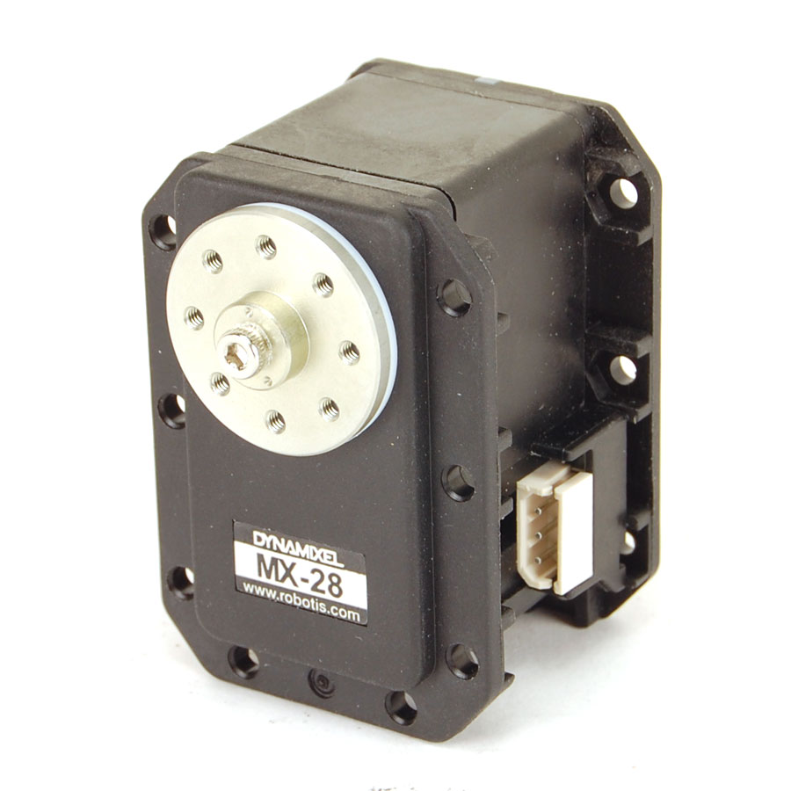

|  |  |  |  |
| --- | --- | --- | --- |
| Operating Voltage | 14.8V | 12V | 11.1V |
| Stall Torque* | 31.6 kg·cm  439 oz·in  3.1 N.m | 25.5 kg·cm  354 oz·in  2.5 N.m | 23.4 kg·cm  325 oz·in  2.3 N.m |
| No-load Speed | 67 RPM | 55 RPM | 50 RPM |
| Weight | 72g | | |
| Size | 35.6 x 50.6 x 35.5 mm | | |
| Resolution | 0.088° | | |
| Reduction Ratio | 193 : 1 | | |
| Operating Angle | 0° ~ 360° or Continuous Turn | | |
| Max Current | 1.4A @ 12V | | |
| Standby Current | 100 mA | | |
| Operating Temp | -5°C ~ 80°+C | | |
| Protocol | TTL Asynchronous Serial | | |
| Module Limit | 254 valid addresses | | |
| Com Speed | 8000bps ~ 3Mbps | | |
| Position Feedback | Yes | | |
| Temp Feedback | Yes | | |
| Load Voltage Feedback | Yes | | |
| Input Voltage Feedback | Yes | | |
| Compliance/PID | Yes | | |
| Material | Metal Gears &  Engineering Plastic Body | | |
| Motor | Maxon RE-MAX | | |

Price: $219.99USD

<https://www.trossenrobotics.com/dynamixel-mx-28-robot-actuator.aspx>

Used by: Poppy Humanoid project

**MG90:**

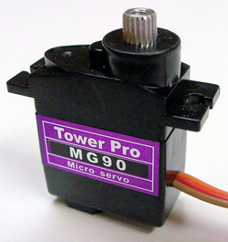

Rotational range: 180

Torque: 2.2 to 2.5 kg/cm

Weight: 4.0g

Size: 23.1*12.2*29mm^3

Gear type: Metal

Bearings: Double Bearing

<https://servodatabase.com/servo/towerpro/mg90>

Price: $23.41USD for 4 servos

Used by: Otto Humanoid

**HV2060MG**

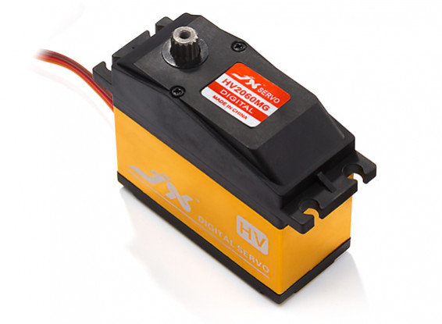

Model No: PDI-HV2060MG

Voltage: 6~7.4V

Stall Torque (6.0V): 48kg

Stall Torque (7.4V): 62kg

Speed (6.0V): 0.15sec/60°

Speed (7.4V): 0.13sec/60°

Dead Band: 4µs 1520µ/330hz

Motor: Coreless

Gears: Metal

Spline Count: 15T

Bearing: 2BB

Dimensions: 65.8 x 30 x 57.4mm

Weight: 200g

Connector: JR type

Servo Wire Length: 265mm

Price: $307.11 HKD

Used by: Inmoov Humanoid Project